Ссылка для цитирования:

Gorelov K.Е. “Psychotherapeutic Stories” as an Aspect of Therapy by Means of Creative Self-Expression by M. Burno (TCSEB) // Anthology of Russian Psychotherapy and Psychology. Issue 10. Proceedings of the First Intercontinental Extraterritorial Congress “Planet of Psychotherapy 2022: Children. Family. Society. Future” (Moscow and online, June 23 – 26, 2022), 2022, 448 p. Pp. 39-47. Available at: https://oppl.ru/up/files/vypuski-antologii/antologiya-v10-06.2022.pdf (Accessed 19 Nov. 2022)



“PSYCHOTHERAPEUTIC STORIES” AS AN ASPECT OF THERAPY BY MEANS OF CREATIVE SELF-EXPRESSION BY M. BURNO (TCSEB)

Kirill Gorelov - Psychiatrist, psychotherapist at Branch №3 of Moscow
Psychiatric Clinical Hospital №13.
Member of All-Russian Professional Psychotherapeutic League (PPL).
Scientific Secretary at Center of Therapy by Means of Creative Self-Expression by M. Burno and Characterological Creatology PPL (Center of TCSEB and CC PPL).
Member of Russian Society of Psychiatrists (RSP)

Moscow, Russia
E-mail: kirillgorelov@ya.ru

Abstract. This article describes the process of using “psychotherapeutic stories” based on the principles of Therapy by Means of Creative Self-Expression by M. Burno (TCSEB). This method can be used for psychoprophylaxis, psychotherapy and psychosocial rehabilitation of healthy people with temporary mental issues, patients with transient mental disorders and patients with chronic mental illness. As a result of such treatment natural protective and adaptive mechanisms are activated, the psychological state and quality of life are improved.

Keywords: TCSEB, Therapy by means of creative self-expression by M. Burno, characterological creatology, psychotherapeutic rehabilitation, psychosocial rehabilitation, psychotherapeutic living-room, psychotherapy by means of creative writing, psychotherapy by means of creative communication with nature, psychotherapy by means of creative traveling, psychotherapy by means of creative immersion in the past, psychotherapy by means of finding the spiritual in the mundane, creative photography, mental health groups, creative characterology groups, psychosocial rehabilitation groups, rehabilitation psychotherapy.

Therapy by Means of Creative Self-Expression by M. Burno (TCSEB) includes a variety of tools allowing us to treat and prevent mental disorders, to preserve mental health, rehabilitate, promote personal development and spiritual maturity.
TCSEB is centered around creativity and one of its forms is creative writing. Both doctors and patients write “psychotherapeutic short stories” that are later analyzed and discussed in groups. There stories help us discover our unique identity, study it, express it, “grow” into it. Simultaneously the doctor helps the group members as they study the basics of psychology, characterology, the nomenclature and criteria for mental disorders – all as part of psychotherapeutic work aimed at recovery and rehabilitation. Short stories can also be published under the author’s real name or a pen-name.
Poems, memoirs, essays, even short notes or diaries are all considered forms of therapeutic self-expression under TCSEB. Often therapy by means of creative writing naturally combines individual TCSEB methods, such as therapy by means of creative communication with nature, therapy by means of creative traveling, therapy by means of creative immersion in the past, therapy by means of finding the spiritual in the mundane, therapy by means of creative photography [1, p. 184-185; 3, p. 233; 4, p. 62, 78-147; 12, p. 19, 34-38]. Each method becomes more deep and complex when used together with the others.
Our main principle is to avoid formality. The short stories should project sincere self-reflection and deep feeling. This is the key to better understanding of one’s unique character and soul. The patient is encouraged to learn more and more about himself, revealing the good along with the bad. Sometimes the aim is to analyze one’s weaknesses find strength in them, the peculiar “strength of weakness” [2, p. 12]. Sometimes the weakness can be transformed and channeled into positive work, into caring about other people.
All this allows one to strengthen one’s individual self, find one’s own way in life, surrounded by one’s “own people”, with a job and hobbies that match one’s personality, discovered and understood through creative therapy. This is the sine qua non of a meaningful and truthful existence. The emotional soul is revived; a deeper insight is achieved allowing one to confidently — and productively — live in one’s own way. To do good and be useful to one’s friends and family, to the society, to oneself. This is how spiritual maturity is attained and inadequate (neurotic) reactions are replaced with healthy ones.
The strengthening of the individual self using the methods of TCSEB is especially effective in patients with endogenous disorders, such as schizophrenics and schizotypal patients whose soul is painfully split and derailed. In their case therapeutic creativity helps restore and redirect to some degree the ideational process and fractured affect thus directly combating mental illness.

M. Burno describes the therapeutic process of attaining self-knowledge and knowledge of others through creativity as follows: “By creating his own art the psychotherapist encourages the patients to create. A short story could just be a cherished childhood memory put to paper. Thus creativity is intertwined with genuine emotion and immersion into the past. Often it goes hand in hand with creative communication with the nature or finding the spiritual in the mundane…» [5, p. 607]. Below is his own short story based on a childhood memory, “A Childhood Evening” [Ibid.]:

“It’s winter twilight and the window is dark and etched with frost. I’m back from school, alone in my family’s room in a communal apartment. The War has just ended. My parents are still at work but I can read, so I grab my reader and start connecting syllables. As I make my way through a children’s story by Tolstoy it fills my heart with sweet melancholy. This is more than just letters becoming words – from between the words, from between the letters emanates a deep and purifying sadness.
Now I understand that what I felt that evening was not only what Tolstoy had felt but also something of my own. I felt Tolstoy’s pity for my own classmate from a poor family with many kids. Sometimes he could not afford a bagel at the school cafeteria but would adamantly decline the snacks we offered him.
I remembered all this while looking at ‘High Water’ by Isaak Levitan – it was on the cover of my reader many, many years ago”.

An important advantage of working with psychotherapeutic (short) stories is that the therapist can address the stories directly to the patients because “Sometimes genuine, healing imagery is much more effective than psychotherapeutic conversation when we aim to unravel the patient’s feelings and make him see an important new perspective. By writing his own stories, the psychotherapist encourages the patients to write about their feelings, their life so that they can better see their own soul, their own purpose, their own way outlined unconsciously in their stories. This is how our patients discover more about themselves and the other group members. It’s especially important for hyperdefensive individuals” [3, p. 149].

In our “therapeutic living-rooms” for group sessions we create a friendly and relaxing atmosphere with the soft light from a table-lamp or candles, with tea, with slides and photos on a screen. Here the group members can take their time analyzing the materials they’re presented with, learning more about their unique traits and the facets of their inner life. Using the basics of characterology they study their own character and the characters of others, the ways of life different characters are manifested in. More and more they realize that human psyche is naturally diverse and that they too can find meaning in life and lead a purposeful existence aimed — in synch with their personal traits — at the common good. This realization in turn provides a stable positive outlook.
TCSEB groups help our patients acquire and develop communication skills that can be used with people from different characterological groups. They learn recognize different characters and act accordingly forming positive bonds.
Patients especially interested in TCSEB methods are usually healthy people with transient mental problems, people suffering from feelings of inadequacy, redundancy and loneliness, those who find it hard to form meaningful relationships, those with who feel scattered, overwhelmed, unsure, lost, out of touch with their inner self, disjointed (often paired with anxiety, depression or existential doubt), those who feel that their individuality is slipping away.
Creative psychotherapeutic sessions are prefaced and accompanied by psychoeducation allowing our patients to discover the basics of psychological typology. Using this basic knowledge the psychotherapist guides the patients towards understanding the peculiarities of their characters and the characters of others. When necessary the patients also study the basic traits of their disorders. This allows them to move on from their disjointed, dazed, amorphous state and attain clarity and integrity. The patients return to themselves, their real selves, harmonious and hopeful. They see more clearly their place in life and their purpose. Our psychotherapeutic and rehabilitative groups are also called mental health groups or creative characterology groups [8-11].
Sometimes beginners in our groups find it hard to understand the mechanism of TCSEB and its methods such as psychotherapy by means of creative writing, psychotherapy by means of creative communication with nature, psychotherapy by means of creative traveling, psychotherapy by means of creative immersion in the past, psychotherapy by means of finding the spiritual in the mundane etc. But they still find our meetings engaging and even short-term therapy proves successful [12, p. 19, 27, 42-57]. With time comes deeper understanding of TCSEB and its potential, stable improvement and long-term remission are attained.

By presenting his own writing at group meetings the psychotherapist achieves more than just practical realization of TCSEB principles. He also promotes a special, warm and trusting exchange, an intimate emotional contact. It is especially important for patients suffering from complex, deep and chronic endogenous disorders such as schizophrenia, schizotypal disorders etc. People who are lonely, who can’t be fully understood or accepted because of their fractured and chronically disoriented psyche. The necessity of such close, trusting exchange was repeatedly underlined by Jakob Klaesi, Max Müller, Ernst Kretschmer, Semyon Isidorovich Konstorum, Pyotr Mikhailovich Zinoviev, Friedrich Mauz and Eugene Brody [1, p. 132-133, 146-147; 4, p. 393].

Intimate emotional contact with the patients is formed in part because by engaging in creative the doctor shares with them the facets of his soul. This is what M. Burno called appearing “sans fard”: “…The creative work of the psychiatrist is inspired and shaped by the principles of TCSEB… He appears sans fard before his patients and reveals to them his unique identity, his soul, warts and all that he, too, is trying to heal. All this has a therapeutic effect and enhances the healing process. ‘Abridged versions’ of TCSEB have proved helpful, but for best results it has to be viewed and implemented in its entirety” [6, p. 7].

By way of example below are several psychotherapeutic stories by the author: “At the Kindergarten”, “Tunnels in the Snow”, “The Summer’s Fading”, “On a Cold Winter Day”.

At the Kindergarten

Every evening parents came to pick up their kids and take them home. There would be times, albeit rarely, when I had to wait.
So I waited and waited. With growing anxiety, I watched despite myself as the group of kids grew smaller and darkness descended. Soon the sun will be gone...
At some point a terrible thought would cut through my worried mind: “They forgot about me!”
My heart beat fast echoing painfully in my head as I grew convinced that they weren’t coming back for me. Ever. I would never come home. I couldn’t even remember the route we took each morning*. It was the end.
The usually buzzing room grew quieter with each passing moment and dejected I would turn to the teacher or the three or four kids remaining: “Hey… Hey listen… They forgot all about me. What shall I do now?”
Some kids would just keep playing. Others with the brusque but sincere comradery characteristic of kids and their short attention spans would try to console me: “Don’t fret! They’ll pick you up any minute now!” The teacher would say, “Don’t worry. Soon… soon someone will come. Go play now”, then fall quiet and turn away.
Meanwhile all but one or two kids were gone. “It’s true. They forgot all about me”, I told myself with horrific certainty.
It never crossed my mind that if the worst came to the worst I would be just fine living in the kindergarten. It was a warm brightly lit place with tasty food and nice beds where we napped after lunch. Kids came every day so I’d have friends to play with. The situation was not at all unbearable. But to me it was hopeless. Come to think of it, my home life wasn’t perfect. My parents’ quarrels scared me. My father’s wrath scared me too because he was always so loud and intense. And I didn’t know when I would slip up again and hear him rumble, “So you’re at it again, aren’t you?!” But now that I had been “forgotten” the mere thought of never again seeing my mom, my grandpa, my dad, my grandmothers, my Auntanya (auntie Anya) and her old dog Bitty, our home – that thought terrified me. I was plunged into utter despair.

Hopelessness burned hot inside my chest. My insides grew cold as if I was plummeting from a giant swing. Finally, a leaden heaviness overcame me.
And then in a blink of an eye the burden lifted when I finally saw a familiar figure coming. I jumped for joy, I was ecstatic.
***
Now, many years later, armed with my knowledge of psychology and characterology and my work experience I see this story in a new light.
What character or at least well-defined character traits produced such pronounced anxiety? Such questions help me better understand not only my past but the present and the future, too: my psychological characteristics, my natural interests and the way I should live my life.
And one more thing... What is behind the acute fear of abandonment, of being “lost” more or less exhibited by many children? We see the same trait in animals, too. Kittens meow fearfully and puppies squeal when upon waking up they don’t see their mother. Such behavior must have a purpose if it was formed in the course evolution. It must be a survival tactic.

*This must have happened on one of my first days at the kindergarten since later on I learned the way home and the fear of being “forgotten” subsided, although its shadow still appeared occasionally in similar circumstances. But it was more of a fleeting worrisome thought than the traumatic certainty that it used to be.
February 4, 2019

Tunnels in the Snow

It’s been so long, an eternity almost but I still vividly remember that ordinary winter evening…
It’s getting dark. I’m about three years old. Grandpa’s pulling me in my little sleigh along the snow-covered Esenin Boulevard. This is what we do in the evenings, me and Gramps, we go on our walk together. Well, actually it’s he who’s walking and I’m just riding along holding my toy shovel. It’s very quiet and the sidewalk is empty save for a few people strolling leisurely. I can see soft fluffy snow falling in the beam of the street light. The snow covers everything; the big flakes rustle ever so slightly alighting on my coat and hat delicately descending atop of each other. The sidewalk’s been cleared by a tractor and the snow is piled high on both sides of it forming even banks. They come up all the way over Grandpa’s knee, they’re probably as tall as I am.
We stop for a while. Smiling, Grandpa takes my toy shovel with its green blade and a brown shaft. “Come on little man! We’ll dig us some snow tunnels!” With sure and precise motions he stabs the snow bank four times. “There… there we go!” The last time he moves the shovel about for a bit and pulls out a great chunk of snow. “Look!” he says triumphantly. “Just look at that tunnel, little man!” There’s a square hole in the bank now going all the way into its mysterious depth. “Now let’s dig another one!” Deftly, with great gusto and a warm laugh he does it all over again.
This new trick amazes me. That’s what my time with Grandpa is, always, amazing and sweet and happy. Reserved and taciturn with the rest of the family, Grandpa always lights up when we’re together.
…And I’m off the sleigh, running over to him, reaching my mittened hands out of the long sleeves of my warm but heavy lamb coat. It’s thick and brown and I still have to “grow into it” properly. “Gramps, let me do it now! Please!” He smiles and hands me the shovel. “Go ahead kid”. Soon I’m making my own tunnels. They are shallow and crooked, but Grandpa’s proud of me. «Now that’s a job well done, little man!” I’m the happiest kid on Earth.
It’s been over 45 years since that winter evening, but I remember every little thing. I hear Grandpa’s dear voice, his kind laughter. For that evening and many others I’m eternally grateful to him. These memories are bittersweet and I want to hold on to them as long as I can.

July 21, 2021 - 3 May, 2022

The Summer’s Fading

Evenings call for a sweater and a fuzzy scarf…
The evening forest is cool and quiet after the rain. Grasshoppers are chirping in the grass but how timid they sound now that we’re past the cusp of Summer. Each day dusk creeps up earlier. It’s mid-August and Autumn’s around the corner.
But Summer takes it’s time leaving, warmth still lingers. I take a long exposure photo of the fading skyline (Fig. 1).

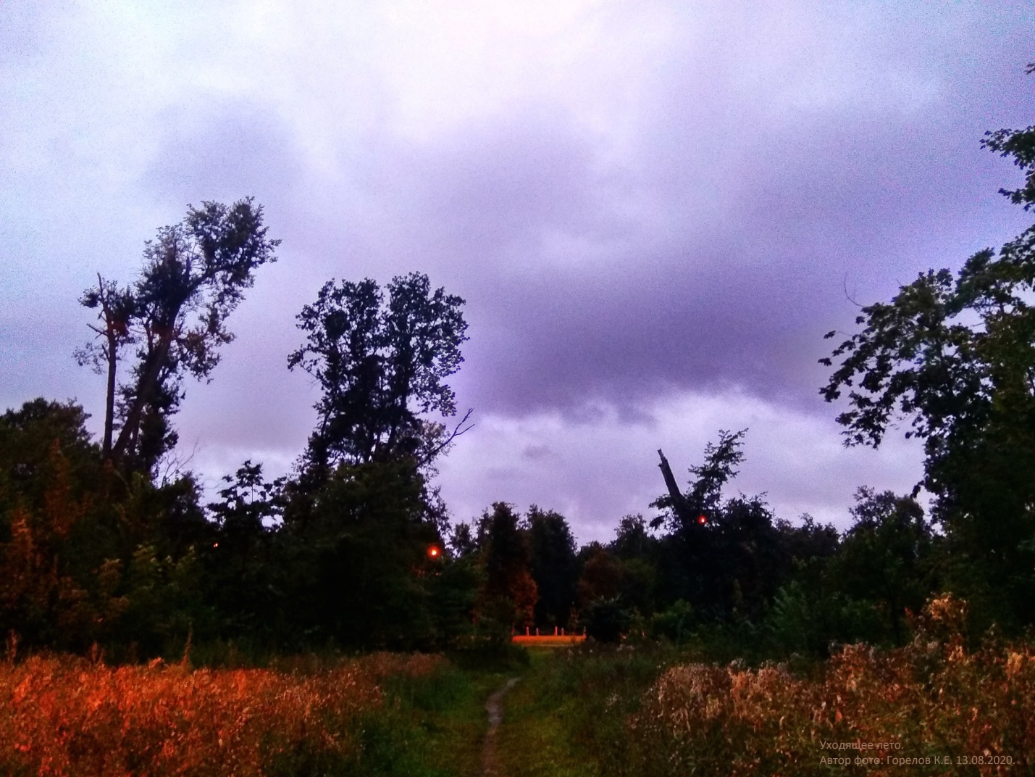
Fig. 1. The Summer’s Fading. August 13, 2020 (photo by author)

The minute I stop and take out the camera, I hear mosquitos whining. They land on my fingers and inside my collar, they bite me and mill in front of my face. They must feel the Autumn coming, too, they want to live some more…

A hokku comes to mind much loved by our group members and myself. We’ve read and analyzed it a lot in our psychotherapeutic meetings dedicated to Reserved Introspective character.
Matsuo Basho, the itinerant Japanese poet, wrote it on a similar evening perhaps — in a different corner of the world, 350 years ago: “Even in Autumn this butterfly / Yearns for life. Hastily it sips / Chrysanthemum dew” (English version of the Russian text translated by V. Markova) [13, p. 581].
As autumn deepens,
a butterfly sips
chrysanthemum dew.
(translation by Michael R. Burch) [20]

Our mosquitos are a far cry from the tender, lonely Japanese butterfly, but they helped me remember something important...

13.08.2020. An evening in August.

On a Cold Winter Day

One day in January, after my “morning shift”, I was walking home through Kuzminsky forest — “our forest” as we call it, although it’s been part of the city for a while now. It seems that my family has lived here on the outskirts forever: my once young parents, grandparents, my great-grandmothers and great-grandfathers. It was a quiet suburb back then where they had a large wooden house with lilac bushes peeking in through the windows in summer and stoves filling the house with fuzzy warmth in winter, stoves crackling with firewood or coal stored up in summer and autumn.
Kuzminsky forest is urbanized now, buzzing agitatedly with trekkers and bikers and outdoors parties with their smoking BBQs. It can get on your nerves sometimes, but quiet corners still remain where, especially on a cold and cloudy day, you can find refuge from the noise (one more reason not to be upset by bad weather). The hidden tracks that make you feel truly alone or at one with the living breathing nature, with the wind rustling in the trees, with woodland smells and birdsong ever changing from season to season.

That cold January day had been filled with important work. New patients with challenging cases whom I wanted to help with all my heart, their gratitude and eagerness to put in work, to figure things out through psychotherapy. I had some administrative work to do at the clinic. I had letters to write to my many colleagues who, like me, were searching for new information, for answers to the serious questions we’re faced with as psychotherapists. Those were my peers, my brothers in arms, so to speak. Such people make up the majority of staff at our Center. A conference was coming up that I had to prepare for… The previous year 2011 hadn’t been easy, but that's how life is in general. You get the good with the bad, the positive with the destructive. At one of my jobs I had encountered a few less-than-professional people, callous and lazy but arrogant to the point where self-promotion was the only thing that mattered to them. More useless red tape was being introduced then taking up the time and energy needed for the actual work, for meaningful therapeutic communication with the patients, for all the things a doctor does if he’s worth his salt. I was tired and anxious and walking home that day I was thinking bitterly about the futility and injustice of it all. I was questioning myself if I even had it in me to keep working like this for much longer.
I took the longest road home through the wood and walked slowly hoping to let go of the negativity, to recuperate mentally and emotionally. I couldn’t keep focusing on my limited resources, on my inability to right all the wrongs, to do everything at once, to abolish every injustice, every meaningless and absurd practice.
My face was tingling with frost, a brisk wind came in bursts. It was January after all. There were scarcely any people around and the day seemed to be dimming already.
And then something made me look up. The dull grey murk had parted for a moment and the setting sun lit up the clouds and the treetops with reddish-orange rays. The new colors were vivid, warm and inviting, uncommonly so for mid-winter. There was a promise there, a new hope, maybe. I rummaged in my messenger bag for my small red digital camera given to me by my friend and colleague V. Rudnev and managed, it seems, to capture some of that magical fleeting light.
Soon the sun was gone again and grey clouds closed over the forest. I stood there for a bit, then moved on thinking, “What was so special about that moment? Why did something inside me resonate with it? It feels like I’m becoming grounded again, it feels like there’s some kind of hope…”
And as the dusk grew thicker, in synch with my measured steps the answer came to me:

The days fade fast,
January’s bitter cold,
But Summer’s seed has already been sown.
The Sun furtively caresses
The pines.

I wrote it down when I got home. Several days later I added the text to the photograph on my computer, had it printed and shared it with my teacher Mark Burno, my friends and colleagues (Fig. 2).

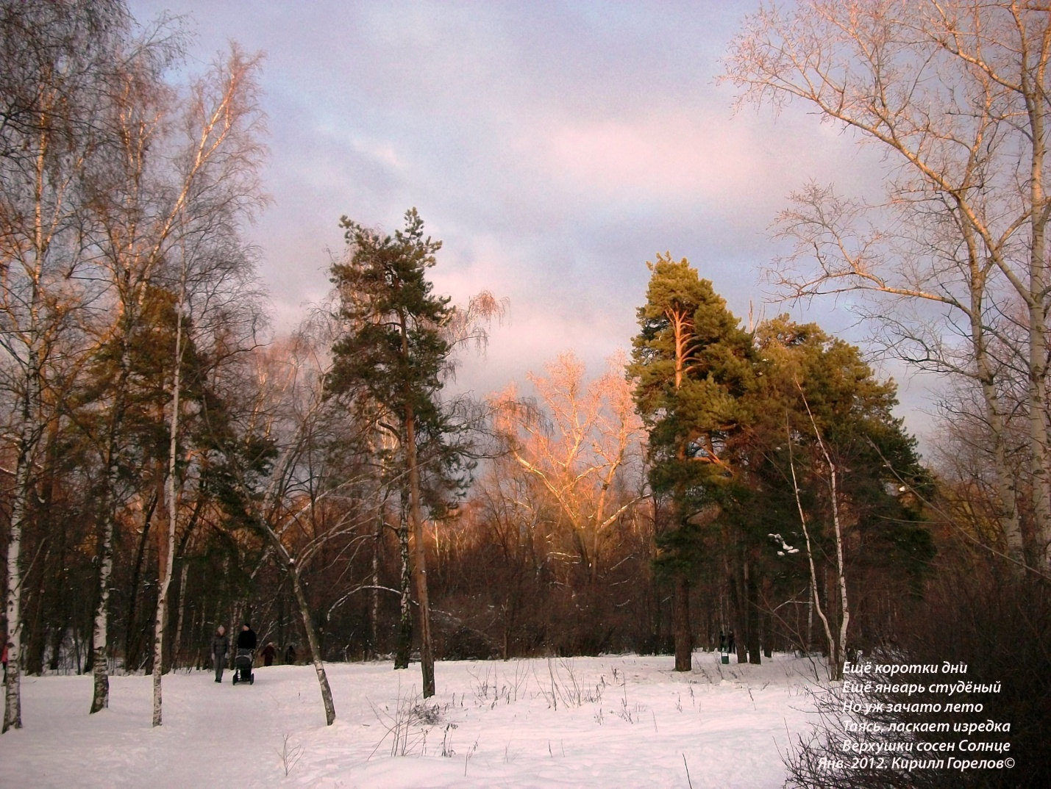
Fig. 2. Kuzminsky forest. January 2012 (photo by author)

What happened that day was a real-life example of Therapy by means of creative self-expression by M. Burno (TCSEB). Here are some of TCSEB methods [1, p. 184-185; 3, p. 233; 4, p. 62, 78-147; 12, p. 19, 34-38] that were at work here:

Method 1 – Therapy by means of creativity. It can be really simple, just a few lines and a photograph. It can be anything: creative writing, painting, photography.

Method 2 – Therapy by means of creative communication with the Nature and studying its many forms in search of those that speak to the nature of your soul and character as opposed to things that leave you indifferent. Here you search for things that resonate with your feelings, that help you understand yourself and strengthen your soul.

Method 5 – Therapy by means of creative immersion into the past (the history of your own family, your country, the world history) and learning about your roots in order to understand yourself more deeply. Here you work on understanding and deepening the feeling of belonging to your “characterological kin”. At the same time, you work to realize your uniqueness, forming a firm belief that you came into this world for a reason, understanding the meaning of your existence and the ways you choose to live.

Walking around the neighborhood, I sometimes think, “This is the road my father would often take” or “This was my grandpa’s favorite spot in the park”. ”My great-grandfather’s house was somewhere around here”. “This is the library where my grandma worked”… Family history comes to mind, the trials that befell my family. I start comparing dates and events. “What have I achieved by the age my father was at that time? What did I do in similar circumcises?” This is where Characterology comes into play [3] and suddenly a new, more complex vision becomes possible of my ancestors’ actions and feelings. Which clarifies, in turn, what I feel and do now. The Past and the Present illuminate and augment each other. This is how we learn more about ourselves and – through ourselves — about our family and family history.
I find myself reaching more and more for our family album, thinking about my parents and their siblings, my grandparents and great-grandparents. How did they overcome their trials, how did they accept things they couldn’t overcome? What they faced in life was unlike and yet in some way similar to what we’re all facing now.
I find myself regretting more bitterly not listening close enough to people now gone, not asking questions. I should’ve asked more about their lives, their thoughts, their memories, their life principles. When I was a little child my grandma’s older sister was still alive, she was born in the 19th century and went to a girls’ school before the Revolution. It seems surreal now… I should’ve treasured their stories more, I should’ve listened closer to my grandpa when he said, as he often would, “Now listen, here’s another one…” I should’ve memorized their advice, even if it seemed “wrong” at the time. All this would’ve helped me understand the previous generations of my family and thus understand myself and my life.
In some instances, I was too young to realize it, in some, too foolish to really value our conversations thinking I had all the time in the world… I didn’t.
All I can do now is pick up crumbs.
…I keep looking at a yellowed photo of my father, Evgeny Stepanovich Gorelov (1942-2018). He’s so young here, only 23 (Fig. 3).

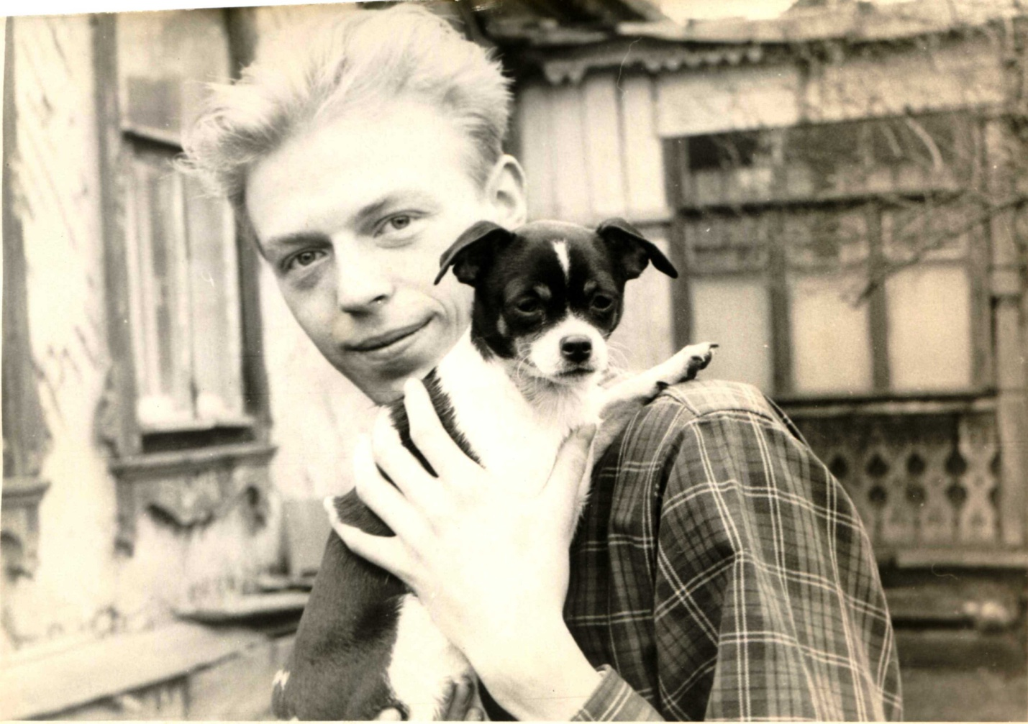
Fig. 3. My father, E.S. Gorelov and Bitty the dog. May 1965 (a photo from author’s family archive)

This is spring 1965, my father, probably too young to be thinking about children (I’m yet to be born 8 years later), can be seen standing in front of the house my great-grandfather Arseny Abramovich Abramov (1862-1920) built at the end of the 19th century in the village of Vishnyaki which has since become part of Moscow. I’m now twice the age my father was then. I compare the events of our lives. The house had seen two Revolutions and two wars. It stood among other country houses with old shady gardens, surrounded by fields and dirt roads — all unremarkable but beloved. Soon the house would be gone: modern neighborhoods sprung up nearby and the villagers had to relocate there as the city continued to grow.
I turn another page and see a photo of my grandmother (in the picture on the right), her sister (left) and Bitty the dog near that same house in August 1965 (Fig. 4).

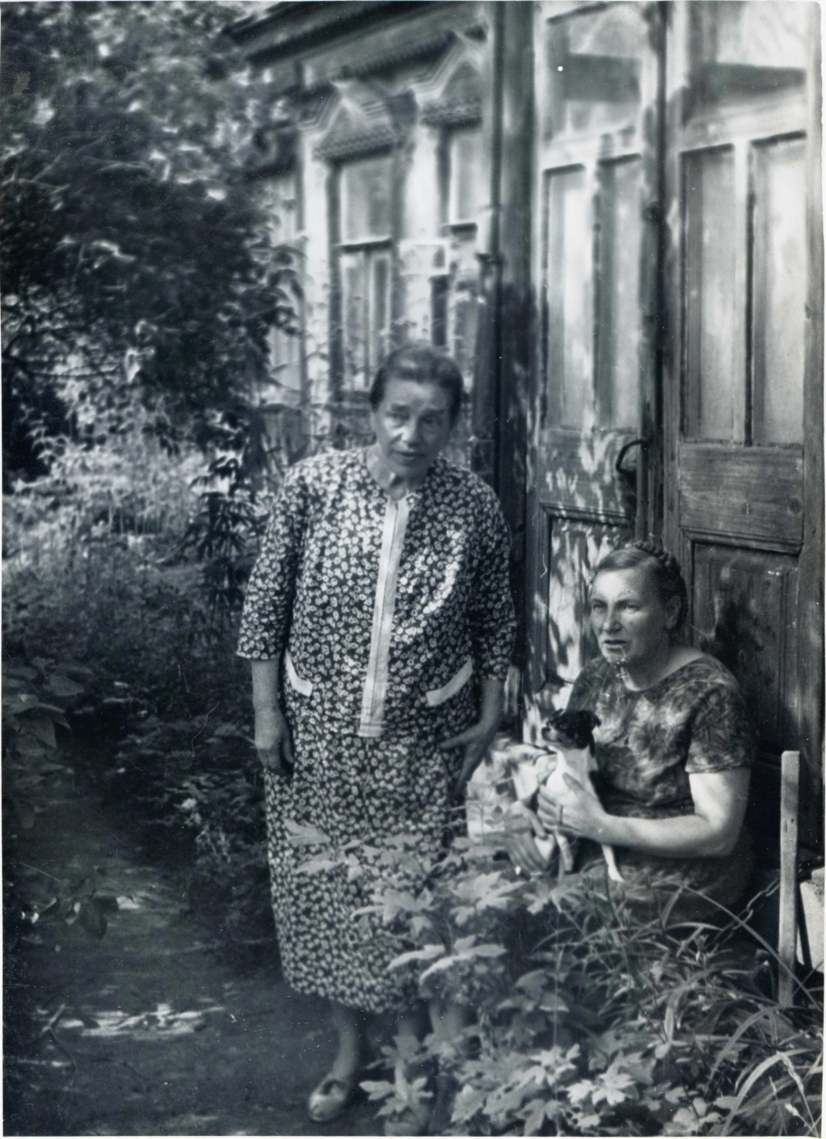
Fig. 4. The sisters, Anna Abramova (left), my grandmother Serafima Gorelova (née Abramova), and Bitty the dog, August 1965 (a photo from author’s family archive)

In their eyes, in their gestures I can feel worry and confusion. “Is this our last summer in our dear old house, in our garden, in the village where we were born? What will the new life bring?” They knew, of course, that once everyone moved to the new neighborhood the village would be torn down to make way for the city. Whoever took the picture had probably asked them to smile but they seem to be deep in their thoughts.
There are more photos in the album dated 1965 than any other year. Why? I’m almost sure now that my loved ones wanted — consciously or unconsciously — to preserve the memory of things that would soon be gone forever. Strange that took me years to realize this.
In the Concise Characterological Questionnaire by M.E. Burno [3, p. 361-364] intended as a supplement for those who wish to discover their character type, one of the statements reads:
3.3. I feel more warmly towards my loved ones when they’re away from me than when they’re near. A positive answer (among other similar answers) is an indicator of Reserved Introspective character [3, p. 42-52] or at least some of its traits. I think I see some of those traits in myself. Or is it that I’ve accumulated enough experience to emphatically understand the past?
But still to feel “more warmly toward someone who’s away” but will eventually return is not as bad as the futility of my love and empathy toward people gone forever. It’s probably inevitable though.
Now that I’m 6 years younger than my grandmother was in that photo, I feel that I’m growing closer to my ancestors in a very special way. I understand them better, warts and all, and worry about them (I know this sounds odd, but hindsight worry seems possible now). I feel sorry that I can’t help them, the people living in those photos. I can neither warn nor protect or console them. They’ll be moving soon, the house will be destroyed, and with it some of the little things they left behind, things that bore witness to the history of my family. The artifacts of a lost world.
My Grandma Sima (Serafima) was 53 when the photo was taken, her older sister Anna, 69. They’d spent their whole lives in our old house in the village of Vishnyaki…

I would now like to touch briefly upon Method 8, Therapy by means of creative traveling, as it intertwines with Method 5. Here you focus on your own unique perception of your surroundings and use it to creatively discover and analyze your personality traits.
As I walk in “our” Kuzminsky forest, remembering my loved ones, my ancestors who lived nearby and walked these same paths, I travel, albeit a very short distance, into the past. And every time my travels reveal something new. The world, like the forest, is changing around me, but I still feel connected to my roots as I remember that this place was dear to those — young and old — who came before me. Method 9 also comes into play here — Therapy by means of finding the spiritual in the mundane and the unique in the ordinary.
A psychotherapist using TCSEB, in the words of M.E. Burno, “participates in the group by engaging his own creativity and revealing to his patients his personality (character)” [12, p. 21], “His stories inspire his patients to write about their lives and feelings to better understand their own soul and spirit, the meaning of their life whose outlines are, sometimes unconsciously, reflected in their short stories. These stories give the patient and the other members of the group a deeper insight into his soul” [3, p. 149].
M.E. Burno, the founder of TCSEB, underlines the advisability of employing “the creative nature of the method in cases when even the most sincere and diligent suggestion, autosuggestion, analysis and instruction cannot help the patient find a way out of crippling anxiety” [3, p. 235].
My own thoughts, feelings, memories that help me better understand myself, ground my soul, stand firm in my vision of self and attain clarity, when written down, can be useful to other people. Those who find that the basic principles and methods of TCSEB resonate with them on a deep level.
Even now, many years since January 2012 the photo I took of the bright reddish-orange rays touching the treetops lifts me up on short and freezing winter days and helps me regain strength and hope. It helps me believe that better times are around the corner and I just have to be strong and patient and stand up for what is right. “We just have to get through the night and fight through the day”, as the brave little warrior Malchish-Kibalchish said to his comrades in a beloved children’s book [7, p. 9].

February 2021 - April 2022

Now, following the example of a kindred spirit A.S. Sokolov, who has written many short stories [14-19] that both our psychotherapeutic community and our group members have come to love, I would like to pose a question to my readers. What do you think about the creative therapy methods described? Would you give them a try? What if they can help? What you have to do is try, in synch with the world around, to find the right mood and moment and single out things that resonate with your creative self. A camera might be of help or even something as simple as a notebook and a pencil.

Bibliography:

1. Burno M.E. Klinicheskii teatr-soobshchestvo v psikhiatrii (rukovodstvo dlia psikhoterapevtov, psikhiatrov, klinicheskikh psikhologov i sotsial'nykh rabotnikov) [The Clinical Community Theatre in Psychiatry (a manual for psychotherapists, psychiatrists, clinical psychologists and social workers]. M.: Akademicheskii proekt, Al'ma Mater, 2009, 719 p.
2. Burno M.E. Nachala terapii tvorcheskim samovyrazheniem: Uchebnoe posobie; Rossiiskaia meditsinskaia akademiia poslediplomnogo obrazovaniia [The Basics of Therapy by Means of Creative Self-Expression: a manual]. M., 1998, 70 p.
3. Burno M.E. O kharakterakh liudei (Psikhoterapevticheskaia kniga) [On Characters (a psychotherapeutic book)]. M.: Institut konsul'tirovaniia i sistemnykh reshenii, Obshcherossiiskaia professional'naia psikhoterapevticheskaia liga, 2019, 592 p.
4. Burno M.E. Terapiia tvorcheskim samovyrazheniem (otechestvennyi klinicheskii psikhoterapevticheskii metod) [Therapy by Means of Creative Self-Expression (the Russian clinical psychotherapeutic method)]. M.: Akademicheskii Proekt; Al'ma Mater, 2012, 487 p.
5. Burno M.E. Emotsional'no-stressovaia psikhoterapiia nevrozopodobnoi shizofrenii, Rukovodstvo po psikhoterapii [Emotional Stress Psychotherapy in Treatment of Pseudoneurotic Schizophrenia (a psychotherapy manual)]. T.: Meditsina, 1985, pp. 585-611.
6. Burno M.E. Tselitel'nye teksty. Chast' 2. [The Healing Texts. Part 2]. Psikhoterapiia [Psychotherapy], 2019, no. 2 (194), pp. 7-52.
7. Arkady Gaidar. Skazka o voennoi taine. O Mal'chishe-Kibal'chishe i ego tverdom slove [A Tale About a War Secret, About the Boy Malchish-Kibalchish, and His Word of Honour]. M.-L.: OGIZ - Molodaia Gvardiia, 1933, 18 p.
8. Gorelov K.E. O potentsial'nykh vozmozhnostiakh shirokogo primeneniia mirovozzrencheskikh idei - bazisnykh printsipov psikhoterapevticheskogo metoda TTS v konsul'tativnoi rabote psikhoterapevtov, psikhologov so vzroslymi i vospitatel'no-korrektsionnoi rabote s det'mi i podrostkami [On the Potential of Wide Implementation of Paradigms and Basic Principles of TCSE in Psychotherapeutic and Psychiatric Consulting of Adults and Corrective Therapy of Children and Teenagers]. Psikhoterapiia [Psychotherapy], 2008, no. 11 (71), pp. 33-40.
9. Gorelov K.E. Ob ispol'zovanii klinicheskoi klassicheskoi psikhoterapii, osnov metoda Terapii tvorcheskim samovyrazheniem M.E. Burno (TTSB) pri organicheskikh trevozhnykh rasstroistvakh (na osnove kliniko-psikhoterapevticheskogo sluchaia) [On Using Clinical Classical Psychotherapy and the Basic Concepts of Therapy by means of Creative Self-Expression by M.E. Burno (TCSEB) in Treatment of Organic Anxiety Disorders (Based on a Clinical and Psychotherapeutic Case Study)]. Psikhoterapiia [Psychotherapy], 2016, no. 11 (167), pp. 87-93.
10. Gorelov K.E. Primer zaniatiia dlia klinicheskoi klassicheskoi gruppovoi raboty v terapii tvorcheskim samovyrazheniem M.E. Burno (TTSB) po rasskazu A.P. Chekhova «Smert' chinovnika» [An Example of a Group Clinical Classical Psychotherapy Based on Therapy by means of Creative Self-Expression by M.E. Burno (TCSEB) Using the Short Story “Death of a Clerk” by A.P. Checkov]. Doklad na Simpoziume KKP Mezhdunarodnogo kongressa. Antologiia Rossiiskoi psikhoterapii i psikhologii [Anthology of Russian Psychotherapy and Psychology]. Vypusk 6, 2018, pp. 13-23 [Online]. Available at: https://oppl.ru/up/files/vypuski-antologii/antologiya2018-v6.pdf/ (Accessed: August 20, 2021)
11. Gorelov K.E. Psikhoterapevticheskii metod terapii tvorcheskim samovyrazheniem (M.E. Burno) i printsipy kharakterologicheskoi kreatologii v lechebnoi, konsul'tativnoi praktike i prepodavaniin [On the Implementation of the Methods of Therapy by Means of Creative Self-Expression (M.E. Burno) and the Principles of Characterological Creatology in Psychotherapy, Psychotherapeutic Consulting and Teaching]. Meditsinskaia psikhologiia v Rossii [Medical Psychology in Russia], 2012, no. 6 (17) [Online]. Available at: http://www.medpsy.ru/mprj/archiv_global/2012_6_17/nomer/nomer04.php/ (Accessed: August 22, 2021)
12. Prakticheskoe rukovodstvo po Terapii tvorcheskim samovyrazheniem. Pod red. M.E. Burno, E.A. Dobroliubovoi. [A Manual on Therapy by Means of Creative Self-Expression. Edited by M.E. Burno and E.A. Dobroliubova]. M.: Akademicheskii proekt, OPPL, 2003, 880 p.
13. Sem' samotsvetov Vostoka: Antologiia vostochnoi klassicheskoi poezii / Sost., vstup. st. i komment. N.B. Kondyrevoi [Seven Gems of the Orient: Anthology of Eastern Classical Poetry]. M.: Shkola-Press, 1995, 640 p.
14. Sokolov A.S. Kriukovskoe ozero (vmesto lekarstv) [The Kriukov Lake (In Lieu of Medicine)]. M.: Izdatel'stvo Rossiiskogo obshchestva medikov-literatorov, 1993, 28 p.
15. Sokolov A.S. Skvortsy (Psikhoterapevticheskie rasskazy, ocherki, stat'i, vospominaniia) Chast' I [The Starlings (Psychotherapeutic Stories, Essays, Articles and Memoirs) Part I]. M.: Izdatel'stvo Rossiiskogo obshchestva medikov-literatorov, 2012, 152 p.
16. Sokolov A.S. Skvortsy (Psikhoterapevticheskie rasskazy, ocherki, stat'i, vospominaniia). Chast' II [The Starlings (Psychotherapeutic Stories, Essays, Articles and Memoirs) Part II]. M.: Izdatel'stvo Obshchestva medikov-literatorov im. M.I. Buianova, 2014, 84 p.
17. Sokolov A.S. Skvortsy (Psikhoterapevticheskie rasskazy, ocherki, stat'i, vospominaniia). Chast' III [The Starlings (Psychotherapeutic Stories, Essays, Articles and Memoirs) Part III]. M.: Izdatel'stvo Obshchestva medikov-literatorov im. M.I. Buianova, 2015, 95 p.
18. Sokolov A.S. Skvortsy (Psikhoterapevticheskie rasskazy, ocherki, stat'i, vospominaniia). Chast' IV [The Starlings (Psychotherapeutic Stories, Essays, Articles and Memoirs) Part IV]. M.: Izdatel'stvo Obshchestva medikov-literatorov im. M.I. Buianova, 2017, 65 p.
19. Sokolov A.S. Skvortsy (Psikhoterapevticheskie rasskazy, ocherki, stat'i, vospominaniia). Chast' V [The Starlings (Psychotherapeutic Stories, Essays, Articles and Memoirs) Part V]. M.: Izdatel'stvo Obshchestva medikov-literatorov im. M.I. Buianova, 2019, 53 p.
20. The Best Haiku Ever: the Greatest Haiku of All Time in a Timeline [Online]. Available at: http://www.thehypertexts.com/Best%20Haiku.htm/ (Accessed: May 30, 2022)

Defensive people exhibit hypersensitivity, insecurities, anxiety, doubt, heightened conscientiousness and guilt. Like many other traits defensiveness possesses positive and negative sides even when it’s disproportionately accentuated and requires correction. This is something we tell our patients. For example, anxiety can manifest as health worries leading to crippling hypochondria, which in turn leads to neediness with the patient demanding special attention and care. Anxiety can also manifest outwards: the patient becomes excessively conscientious and worries constantly about inadvertently hurting others with his words or actions. Defensiveness can be reflected in daily life as indecisiveness, sluggishness, procrastination or extreme attention to detail, meticulousness, a tendency to double- and triple-check every little move.
Center of Therapy by Means of Creative Self-Expression by M. Burno and Characterological Creatology PPL (TCSEB and CC PPL).
As part of the urban development program in the USSR, villagers were provided with apartments free of charge in the new city neighborhoods, but it was not unusual for the some people to be reluctant to move. It was impossible to refuse to move. The refusal was considered illegal.
Also translated as Nipper-Pipper.
This is a story of a noble and valiant boy called Malchish-Kibalchish who fought against corrupt, deceitful, selfish, greedy, insolent people.

